J.D.K(Version more 2021.08.10)
Step 1.
JAVA_HOME
E:\JDK210810
*Attention please, the path based on your own installation way. Meanwhile, the name ‘JAVA_HOME’ can be your like, but must be the same the follow.
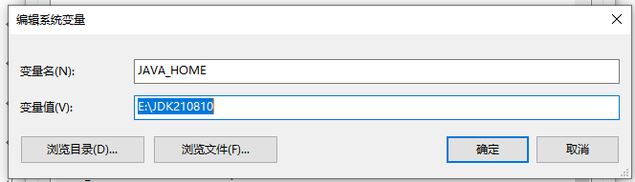
Step 2.
%JAVA_HOME%\bin
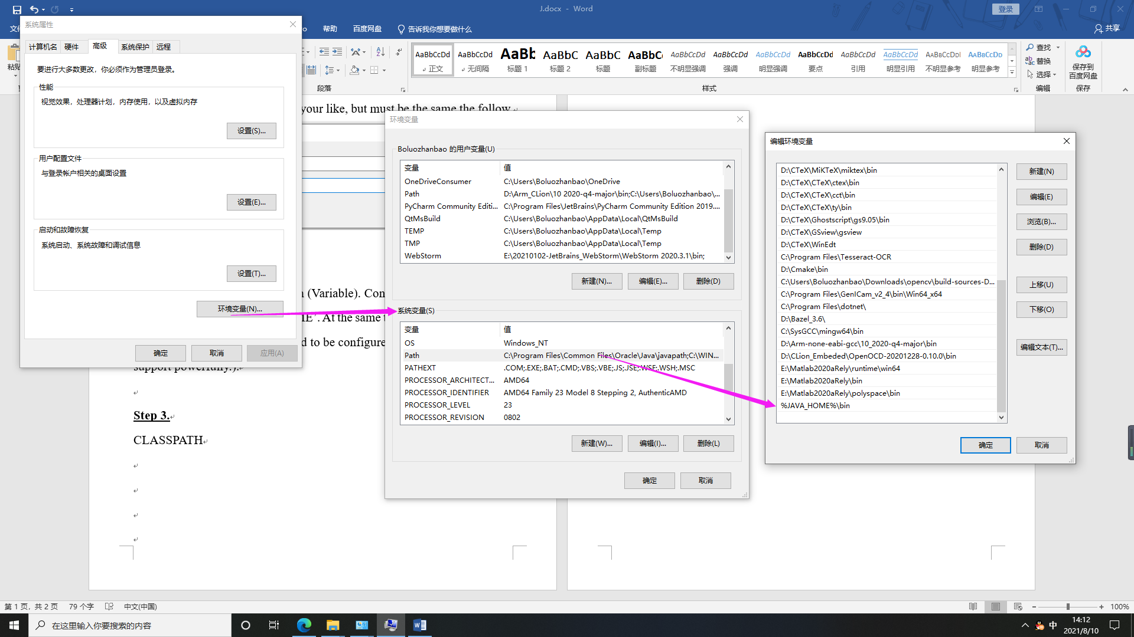
*This is based on the system path (Variable). Configure it correctly, and be sure that the name is ‘JAVA_HOME’. At the same time, there is an important thing here, the J.R.E path not need to be configured independently (Version support powerfully).
Step 3.
CLASSPATH
$$.;\%JAVA_HOME\%\backslash lib$$
*This also belongs to the system var. Attention please, before the ‘%’, there is ‘.;’ should not be ignored.
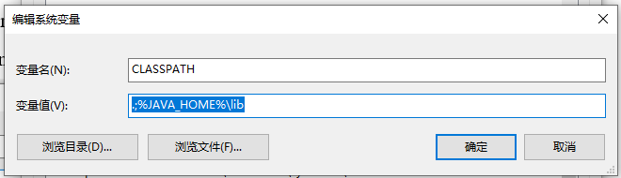
The same as before, the ‘tools.jar’ not need to be configured (Maybe different from the former Version 2021.08.10).
When your have finished, check it by console command:
-java -version (‘$javac$’ for check compile)
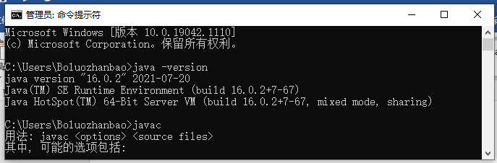
2021.08.10 Here, Hefei.

